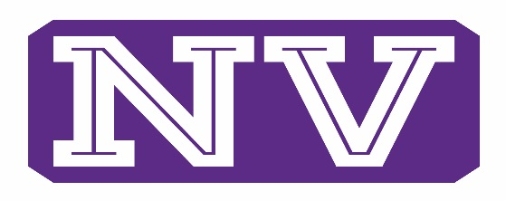
ATHLETICS

NVSD GUIDELINES FOR RETURNING TO ATHLETIC ACTIVITIES
The Pandemic has created a multitude of challenges most of us never dreamed of. Returning to athletic activities creates some unique challenges to ensure safety for everyone involved. This document is intended to convey and specify the guidelines NVSD will implement to properly and safely return to athletic activities.
As with many other areas connected to COVID 19, these guidelines are “fluid” and will be adjusted as directed the State of Washington, OSPI, Risk Management Pool, WIAA, and Whatcom County Health Department. The following components are part of our detailed plan to safely “Return to Activity”
- Follow the “Return to Activity” guidelines as recommended by the NFHS, and WIAA.
- Utilize the “Return to Activity” procedural checklist for each phase as recommended by “Final Forms”, a WIAA approved document.
- Implement, and adhere to all waiver documents provided to us by our Risk Management Pool. These include: Participants, Visitors, Volunteers, Facilities, and Screening of Athletes.
- Implement and adhere to all sport specific guidelines as put forth by both the NFHS, and WIAA.
- All these documents will be available to view and download on our NVSD Athletics Home page on our NWC Athletics page. This is the link to that page. http://www.nwcathletics.com/index.php?pid=0.1.11.0.300
- All coaches paid and volunteer, will be trained in all “Return to Activity” protocols, activities, appropriate to the current COVID phase, and their particular area(s) of expertise. This will be included with an educational packet.
- These guidelines will also be given to parents/guardians of all participating athletes.
Continued next page

- Specific guidelines and steps for sanitizing, cleaning of equipment, and facilities can be found in both the NFHS and WIAA Re-opening guidelines.
- NVSD coaching staff will take steps to coordinate times and workouts to be mindful of multisport athletes, so these athletes do not feel they need to choose one sport over another.
- All athletes, and coaches will fill out the Participation waivers prior to any organized activities.
- All athletes will need to have a current physical on file in accordance with WIAA guidelines, or obtain an updated one.
- All participating coaching staff will be trained in areas of Health Screening, workout precautions, use of mask, Infrared Thermometers, and Social Distancing measures appropriate to our current activity Phase.
- At this time, NVSD does not plan to re-open facilities to outside (non school activities) until Whatcom County enters Washington State’s Phase 3 of the Safe Start Plan.
- All workouts/practices for each group will be documented and available upon request.
Thanks,
NVSD

For questions or concerns please feel free to contact the following people
Medical or Health questions: Liza Diaz NVSD Nurse Liza.Diaz@nv.k12.wa.us
All other questions please refer to either:
Matt Galley NVHS Principal matt.galley@nv.k12.wa.us
Tom Harmon NVSD Athletic Director tom.harmon@nv.k12.wa.us

